Practical No. 1

Q1. Defining different types of variables and performing arithmentic operations

Code:

fun main() {
val num1 = 12
val num2 = 3
var result: Int
result = num1 + num2
println("Addition of num1 + num2 is $result")
val num3 = 12.4
val num4 = 3.5
var result1: Double
result1 = num3 - num4
println("Substraction of num3 - num4 is $result1")
val num5 = 5.75F
val num6 = 3.75F
var result2: Float
result2 = num5 * num6
println("Multiplication of num5 * num6 is $result2")
val num7 = 55000000000L
val num8 = 15000000000L
var result3: Long
result3 = num7 / num8
println("Division of num7 / num8 is $result3")
val num9 = 12
val num10 = 3
var result4: Int
result4 = num9 % num10
println("Module of num9 % num10 is $result4")
}
Output:
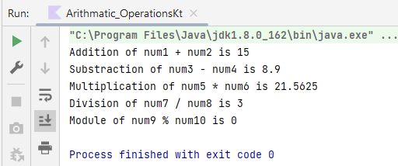
Q2. Program to receive user input and display result

Code:

fun main()
{
println("Enter First Number:")
var num1 =readLine()
var n1=Integer.parseInt(num1)
println("Enter Second Number:")
var num2 =readLine();
var n2=Integer.parseInt(num2)
println("Addition of $num1 and $num2 is "+(n1+n2));
}

Output:

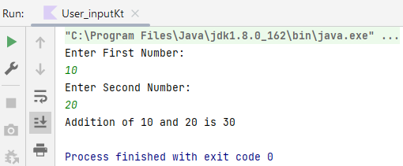

Q.3 Program to study conditional statements: if,nested if, if
else-if, and 'when' statement

- If statement

Code:

fun main()
{
val a = 10
if(a%2==0)
{
print("$a is even number.")
}
}

Output:

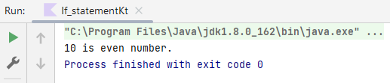

- Nested if statement

Code:
fun main()
{
var a = 20;
if(a%2==0)
{
print("$a is even number.");
if (a % 2 != 0)
{
print("$a is odd number.");
}
}
}

Output:

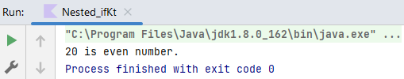

- if-else-if statement

Code:
fun main()
{
val a = 15
if(a%4==0)
{
print("$a is divisible by 4.")
}
else if(a%6==0)
{
print("$a is divisible by 6.")
}
else if(a%3==0)
{
print("$a is divisible by 3.")
}
else
{
print("Try it again")
}
}

Output:

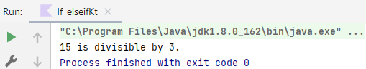

- 'When' statement

Code:
fun main()
{
var day=2;
var dayname:String= when (day)
{
1->"Sunday"
2->"Monday"
3->"Tuesday"
4->"Wednesday"
5->"Thursday"
6->"Friday"
7->"Saturday"
else -> {"Invalid day number"}
}
println("Day is $dayname");
}

Output:

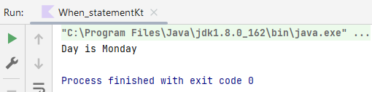

Q4. Program to study loop statements- for,while,do-while in kotlin

- For loop

Code:

fun main()
{
//for loop
var number =arrayOf (5,10,15,20,25)
var sum=0
println("Number Array")
for(item in number)
{
print(" "+item+" ")
sum = sum + item
}
println("$sum")
//for loop with range
println("Printing Number from 1 to 15")
for(items in 1 .. 15)
{
print(" "+items+" ")
}
}
Output:

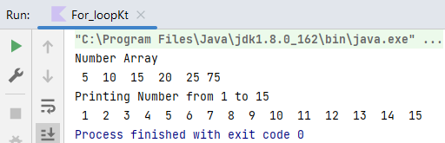

- While loop

Code:
fun main()
{
var x = 1;
while(x<=10)
{
print(" "+x+" ");
x++;
}
}

Output:

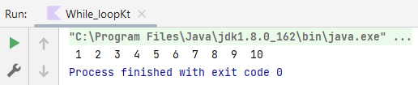

- Do-while loop

Code:

fun main()
{
var x = 1;
do{
print(" "+x+" ");
x++;
} while(x<15);
}

Output:

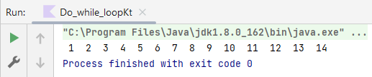

Q5. Declaring functions and returning values from function in
Kotlin

Code:

fun myfunction1():Int
{
println("This is myFunction1()")
return 10;
}
fun myfunction2(x:Int,y:Int):Int
{
println("This is myFunction2()")
return x*y;
}
fun main()
{
var x:Int=myfunction1();
println("Value retured by myfunction is $x")
var s:Int=myfunction2(x=10,y=10);
println("Value returned by myfunction2 is $s")
}

Output:

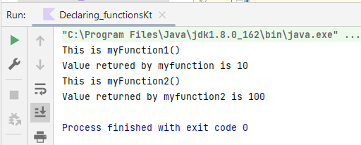

Q6. Working with class, objects, constructors and inheritance
in Kotlin

- class, objects, constructors

Code:
class Students(val rollno:Int,var name:String, var address:String)
{
fun display()
{
println("The students's roll number is $rollno")
println("The students's name is $name")
println("The students's from $address")
}
}
fun main()
{
var c= Students(rollno=20,name="Sanika Munankar",address="Vengurla")
c.display()
}

Output:

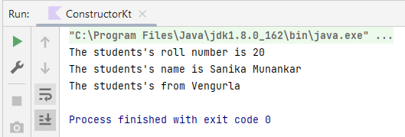

- Inheritance

Code:

open class parent_class
{
var x:Int=5
fun show()
{
println("$x from parentclass")
}
}
class child_class:parentclass()
{
var m:Int=10
fun display()
{
println("$x from childclass")
println("$m from childclass")
}
}
fun main()
{
var c=child_class()
c.x=100
c.display()
c.show()
var p=parent_class()
p.show()
}

Output:
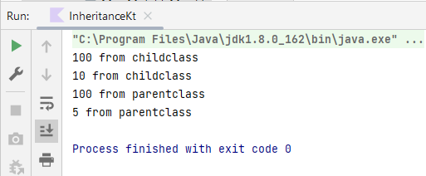

Q7. Working with delegation and extension functions and companion object.

- Delegation

Code:

interface Interface
{
fun method()
}
class myclass:Interface
{
override fun method()
{
println("This is Overridden method")
}
}
//Delegation
class child(b:Interface):Interface by b
{
fun showchild()
{
println("This is showchild() from childclass")
}
}
fun main()
{
var b=myclass()
child(b).method()
var c=child(b)
c.showchild()
c.method()
}

Output:

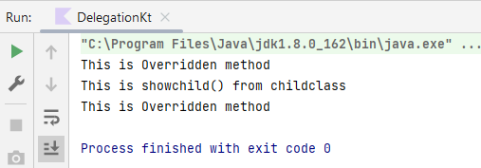

- Extension function

Code:

class myclass2
{
fun method1()
{
println("I am inside method1()");
}
}
fun myclass2.method2()
{
println("I am inside method2()");
}
fun main()
{
var m=myclass2()
m.method1()
m.method2()
}

Output:

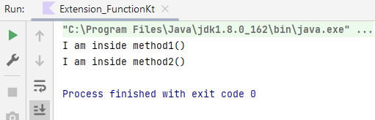

- Companion Object

Code:
class mclass
{
companion object
{
fun method1()
{
println("I am inside method 1")
}
fun method2()
{
println("I am inside method 2")
}
var v1:Int=5
}
}
fun main()
{
mclass.method1()
mclass.method2()
print("Variable inside Companion Object:"+mclass.v1)
}
Output:

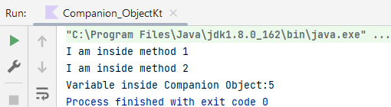

Q.8 Working with collections (List,Map,Set) in kotlin.

- List

Code:

fun main()
{
var List1=listOf(1,2,3,4,5,6)
println("Immutable List:")
for(item in List1)
{
print(" "+item+" ")
}
println()
println()
println("Using indexOf method to search index of an element: ")
var i=List1.indexOf(5)
if(i==1)
{
println("Element is not part of list1")
}
else
{
println("Element 5 is available at index $i in list1")
}
println()
var sublist=List1.subList(2,6)
println("List from index 2 to 6:")
for(item in sublist)
{
print(" "+item+" ")
}
println()
println()
println("Using List Iterator:")
var it: ListIterator<Int> = List1.listIterator()
while (it.hasNext())
{
val i = it.next()
print(" $i ")
}
println()
println("-------------------------------------------------")
println("Mutable List")
var mutableList1=mutableListOf("one","two","three",4)
for(item in mutableList1)
{
print(" $item ")
}
println()
println()
println("After Adding element in mutable list")
mutableList1.add(0,"Zero")
mutableList1.add("Five")
for(item in mutableList1)
{
print(" $item ")
}
println()
println()
mutableList1.removeAt(2)
mutableList1.removeAt(4)
println("After removing updated mutable list")
for(item in mutableList1)
{
print(" $item ")
}
}

Output:

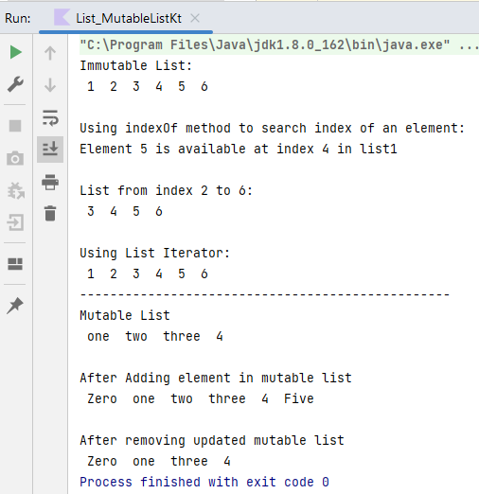

- Map

Code:

package collections
fun main()
{
println("Immutable Map")
var map1=mapOf(1 to "Roll No. 1",2 to "Roll No. 2",3 to "Roll No. 3")
for(item in map1.keys)
{
println("Key is $item and its associated value is "+map1.get(item))
}
println("--------------------------------------------------")
println("Mutable map")
var mutmap=mutableMapOf(1 to "Roll No. 1",2 to "Roll No. 2",3 to "Roll No. 3",4 to "Roll No. 4")
mutmap.put(5,"Roll No. 5")
for(item in mutmap.keys)
{
println("Key is $item and its associated value is "+mutmap.get(item))
}
}

Output:
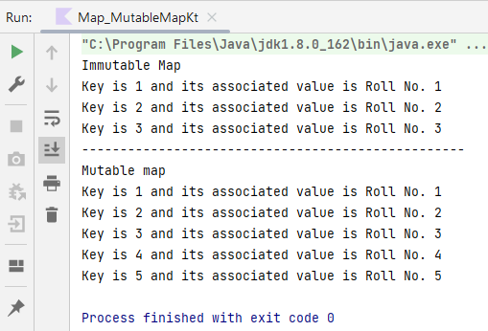

- Set

Code:

package collections
fun main()
{
println("Immutable sets")
var set1=setOf(10,20,30,40,50,60)
var set2=setOf(20,30,40)
println("Immutable set1")
for(item in set1)
{
print(" $item ")
}
println()
println()
print("Immutable set2")
println()
for(item in set2)
{
print(" $item ")
}
println()
println()
println("size of set1 is : "+set1.size)
println("size of set2 is : "+set2.size)
println("set1 contains 40 is "+set1.contains(40))
println("set1 contains all elements from set2 is "+set1.containsAll(set2))
println("set2 contains all elements from set1 is "+set2.containsAll(set1))
println("------------------------------------------")
println("Mutable set")
var mutset1= mutableSetOf(10,20,30,40,50)
for(item in mutset1)
{
print(" $item ")
}
println()
println()
mutset1.add(60)
mutset1.addAll(set2)
println("After Adding Element in Mutable set")
for(item in mutset1)
{
print(" $item ")
}
println()
println()
mutset1.remove(10)
mutset1.removeAll(set2)
println("Mutable list after removing elements")
for(item in mutset1)
{
print(" "+item+" ")
}
}

Output:

